CS 6375

ASSIGNMENT ____1________

Names of students in your group:

Sanmati Marabad (sxm210368)

Sandeep Chikkapla Siddappa (sxc220127)

Number of free late days used: _1___________________   
Note: You are allowed a **total** of 4 free late days for the **entire semester**. You can use at most 2 for each assignment. After that, there will be a penalty of 10% for each late day.

Please list clearly all the sources/references that you have used in this assignment.

ReadMe

Libraries required:

Install the below libraries before running the python code.

1. Numpy
2. Pandas
3. Sklearn
4. Matplotlib

Dataset : Student Performance Evaluation

<https://archive.ics.uci.edu/dataset/856/higher+education+students+performance+evaluation>

How to run?

Run command :

1. python part1.py

After running part1 the best Mean Squared Error (MSE) value will be printed and also the 16 graphs will be plotted for different learning rates and different number of iterations.

Check for the terminal for best MSE with specified learning rate and number of iterations and check for the same in graph.

2.Python part2.py

In this part, we use the sklearn library to calculate mean squared error.

Below are the used libraries:

from sklearn.model_selection import train_test_split

from sklearn.linear_model import SGDRegressor

from sklearn.metrics import mean_squared_error

The calculated MSE will be printed on the terminal which is calculated for the same dataset used in part 1.

Part 1:

Logs:

<https://github.com/SanmatiM/CS6375-Assignment1/blob/main/log_part1.txt>

Plots:

Optimum values plot:

Output:

Questions:

1. Are you satisfied that you have found the best solution? Explain.

Yes, We have found the better and optimal solution for the dataset of student performance evaluation based on MSE.

As the MSE values from our trained model is comparatively less than the inbuilt SGDRegressor.

Part 2:

Logs :

<https://github.com/SanmatiM/CS6375-Assignment1/blob/main/log_part2.txt>

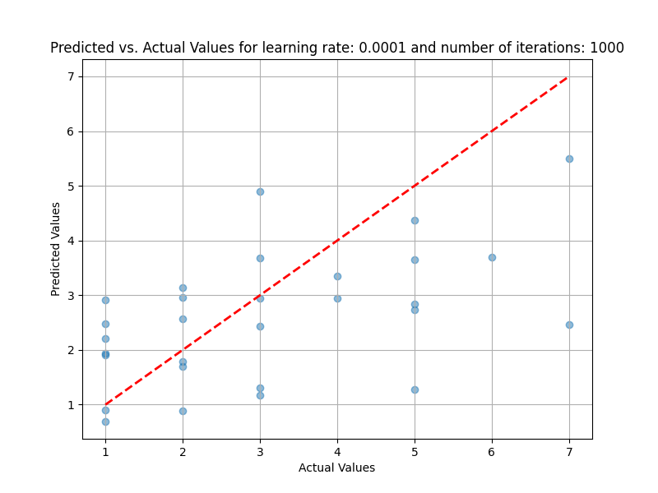

Optimum values plot:

Output:

Are you satisfied that the package has found the best solution. How can you check. Explain.

No, as per out dataset and data model, the MSE values from our model is comparatively less than the SGDRegressor package where MSE vales are relatively high from the package.